SISTER NIVEDITA MONTESSORY SCHOOL
NURSERY
HINDI
PRACTICE 3 PAGES
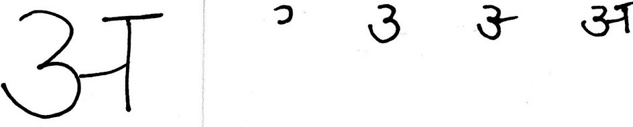
WRITING PATTERN EX BOOK 1- COMPLETE PG 11 & 12.
WRITING PATTERN EX BOOK 2 - COMPLETE PG 3.
PRACTICE NUMBER 1(ONE) - GO- OVER.

PRACTICE NUMBER 2 (TWO)- GO -OVER
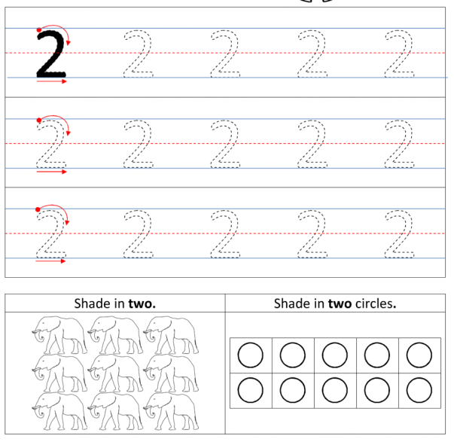
PUT YOUR FINGER & READ “C” LETTER WORDS FROM PICTURE PRIMER BOOK. (PG.NO-5).
PUT YOUR FINGER & READ 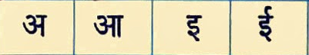 FROM AKSHAR PARICHAY (PG.NO- 2&3).
PUT YOUR FINGER & READ “1” TO “30” FROM FILE.

